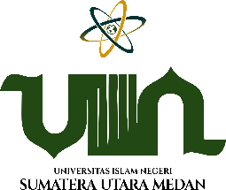

JURNAL TARBIYAH

E-ISSN : 2597-4270 | P-ISSN : 0854-2627
Volume 30, Number 2, December 2023, pp. xx-xx

MAPING THE DEVELOPMENT OF CRITICAL THINKING IN ISLAMIC EDUCATION USING BIBLIOMETRIC ANALYSIS

Fauziyah Qurrota A’yun Tamami¹, Mohammad Zakki Azani^{2,} Muhamad Subhi Aprianto³, Saddam Husein⁴

^{1,2,3} Universitas Muhammadiyah Surakarta, Jawa Tengah, Indonesia
⁴ International Islamic University Malaysia, Kuala Lumpur, Malaysia
g000204332@student.ums.ac.id¹, m.zakkiazani@ums.ac.id², msa617@ums.ac.id³, sh.husein@live.iium.edu.my⁴

DOI : http://dx.doi.org/10.30829/tar.v30i2.XXXX

ARTICLE INFO | ABSTRACT
Article History  Received : July 1, 2023  Revised : December 15, 2023  Accepted : December 15, 2023 | This study aims to determine the mapping of the development and direction of research on Critical Thing of Islamic Education in publications indexed by the Scopus database. This study used bibliometric analysis techniques to explore all publications indexed in the Scopus database on Critical Thinking of Islamic Education from 1994 to 2023. The data obtained were analyzed using Excel and R/R-Studio. VOSviewer is used to perform visual analysis of keyword occurrence and document citations in a stimulating manner. Researchers found 3,702 publications that fit the function, subject, and criteria set. The results of this study show an annual growth rate. The papers are analyzed in terms of publications by field of science, the number of studies published annually. The bibliometric analysis performed was limited to Scopus data. Other national and international databases were not taken into account in the study. The limitation of this study is only taking data sets or meta data in publications indexed by Scopus. This study presents a brief overview of the literature accessible to researchers working in the field of Critical Thinking of Islamic Education and provides recommendations for future research.
Keywords
Islamic Education1,
Critcal Thinking2,
Learning3,
Knowledge4

Kata Kunci  Pendidikan Islam1,  Berfikir Kritis2,  Pembelajaran3,  Pengetahuan4 | ABSTRAK
 | Penelitian ini bertujuan untuk mengetahui pemetakan perkembangan dan arah penelitian Critical Thingking Pendidikan Islam pada publikasi yang terindeks database Scopus. Penelitian ini menggunakan teknik analisis bibliometrik untuk mengeksplorasi semua publikasi yang terindeks dalam basis data Scopus tentang Critical Thinking Pendidikan Islam dari tahun 1994 hingga 2023. Data yang diperoleh dianalisis menggunakan Excel dan R/R-Studio. VOSviewer digunakan untuk melakukan analisis visual tentang kemunculan kata kunci dan kutipan dokumen secara stimultan. Peneliti menemukan 3.702 publikasi yang sesuai dengan dengan fungsi, subjek, dan kriteria yang ditetapkan. Hasil penelitian ini menunjukkan tingkat pertumbuhan tahunan. Makalah-makalah tersebut dianalisis dalam hal publikasi berdasarkan bidang ilmu, jumlah studi yang diterbitkan setiap tahun. Ananlisis bibliometric yang dilakukan terbatas pada data Scopus. Basis data nasional dan internasional lainnya tidak diperhitungkan dalam penelitian ini. Keterbatasan penelitian ini hanya mengambil data set atau meta data pada publikasi yang terindeks Scopus. Penelitian ini menyajikan gambaran singkat tentang literatur yang dapat diakses oleh para peneliti yang bekerja di bidang Critical Thinking Pendidikan Islam dan memberikan rekomendasi untuk penelitian selanjutnya.

Introduction
Critical Thinking is an important skill in Islamic Education that helps learners to find the meaning of a concept critically for one's own needs or even contribution to Society (Arif, 2019; Hamzah et al., 2018). It involves engaging in discourse that is grounded to intellectual standards such as clarity, precision, rigor, and logic, and using analytical skills with a basic value orientation that emphasizes intellectual humility, intellectual integrity, and a fair mind (Kazmi, 2020).
Islamic education is one of the fields of education that continues to grow and is increasingly important in the current era of globalization (Mouftah, 2012; Nawi et al., 2014) The ability to think critically is one of the skills that are needed in Islamic education, because it can help students to understand and analyze various concepts and theories taught in Islamic education (Agbaria, 2019; Alkouatli, 2018; Francis et al., 2020) Therefore, a lot of research has been conducted to understand the development of critical thinking skills in Islamic education (Nasir Zakaria et al., 2019; Sahakyan, 2018; Sai, 2018).
Critical thinking is defined as reflective skepticism, and is a way to approach problems and make decisions (Altinyelken, 2021). According to research, critical thinking is seen as a skill that develops at later stages in life, when children become adults and acquire more knowledge during their education. In Islamic education, critical thinking is a moral commitment, and engaging in critical thinking is judged on its moral values (Hamzah et al., 2018).
Cut Shabrina Dzati Amani stated in her research that the relevance of the concept between critical thinking and QS. Al-Alaq verses 1-5 are in harmony with the components contained in the critical thinking process (Dzati Amani, 2023).
Madrasah Ibtidaiyah (MI) has transformational leadership characteristics towards the vision of 21st century education described with code 4I combined with 4C (critical thinking and problem solving, creativity and innovation, communication, and collaboration), this research was conducted by Muhammad Shaleh Assingkily using an approach kualitatif (Assingkily & Mesiono, 2019).
The ability of critical thinking in jurisprudence subjects based on five indicators in the WGCTA test, namely conclusions, introduction to assumptions, deduction, interpretation, and evaluation of arguments, this statement was examined by Fatur Rohman with a qualitative research approach (Rohman, 2021).
Nursafra Mohd Zhaffar stated in her research that individual Islamic Educator Teachers (GPI) are readily exposed to critical thinking in higher education centers. Likewise with the basic science of Islamic Education content related to creed, sharia and morals. Personal initiatives on the part of GPI to polish this potential are needed by cultivating knowledge (Mohd Zhaffar et al., 2016).
A. Syaifullah in his research with a qualitative approach stated that Islamic Education must remain consistent even during the Covid-19 period, with the concept of forming critical reason through changing the paradigm of Islamic education learning from normative to empirical realm (Syaifullah, 2021).
So far, no previous research has been found that discusses Critical Thinking of Islamic Education using quantitative approaches and bibliometric analysis. In fact, to get maximum results, a philosophical and systematic foundation is needed.
Therefore, it is necessary to conduct research related to this, in this research researchers use bibliometric analysis with the aim of determining the mapping of developments and research directions related to Critical Thinking of Islamic Education.

Research Methodology
This study uses comprehensive bibliometric analysis in the form of document and network analysis. The information was obtained using the Boolean search engine to comb through the Scopus database between 1994 and 2023. The search will be conducted on September 14, 2023 at 11:00 a.m. Researchers use R/R-Studio tools, VOSviewer and Microsoft Excel to analyze documents, citations, and networks.
The stages taken by researchers are as follows, among others: The first stage, researchers will conduct a literature review on related themes to ensure relevant research is carried out with bibliometric topics. In addition, literature review is useful for determining appropriate keywords and is considered to represent the scope of research.
In the second stage, researchers used Boolean operators (TITLE-ABS-KEY (islamic AND education) AND NOT TITLE-ABS-KEY (critical AND thinking)) to search Scopus which yielded 3,702 documents. Further filtaration was performed with the Boolean operators (LIMIT-TO (DOCTYPE, "ar")) AND (LIMIT-TO (LANGUAGE, "english")) to limit only English documents and articles as document types, resulting in a final document of 272.
The third stage, analysis is carried out on the final document search using Scopus analyzer and R and Rstudio to find out the number of documents per year, documents by journal, author, affiliation, country, and subject or field. Furthermore, analysis of the document network level was carried out by reading visualizations through VOSviewer and Microsoft Excel data processing.
The detailed research procedure can be seen in figure 1 below.
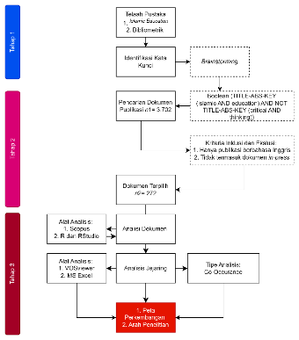
Figure 1 Research Flow

Results
- Document Analysis
Table 2.1.1 provides an overview of the 3,701 documents collected over 29 years. Including 8,231 authors, 1,215 single authors, 13.29% international authorship collaborations, 134932 references with an average citation per document of 7,781 citations.
Table 2.1. 1 Summary of The Main Information
MAIN INFORMATION
Timespan | 1924:2023
Sources (Journals, Books, etc) | 1490
Documents | 3701
Annual Growth Rate % | 5.76
Document Average Age | 7.78
Average citations per doc | 7.781
References | 134932
DOCUMENT CONTENTS
Keywords Plus (ID) | 4805
Author's Keywords (DE) | 8467
AUTHORS
Authors | 8231
Authors of single-authored docs | 1215
AUTHORS COLLABORATION
Single-authored docs | 1357
Co-Authors per Doc | 2.68
International co-authorships % | 13.29
DOCUMENT TYPES
article | 3701
Figure 2.1.1 shows the development of publications in the field of Critical Thinking that publications were first published in 1994 with a total of 2023 publications, since 2011 shows the development of an increase in publications with a decrease that is not too significant (Judi et al., 2019; Mouftah, 2012; Nasir Zakaria et al., 2019; Sahakyan, 2018; Sai, 2018).

Figure 2.1. 1 Year Charts

Figure 2.1.2 shows the name of the author who often appears, namely Suyadi with 6 articles that have been published, then continued with Hamzah, M.I, Nor M.R.M and Nuryana, Z who have similarities with 5 publications.

Figure 2.1. 2 Name of Authors Charts

Figure 2.1.3 The most published university is University Kebangsaan (Dzulkifli, 2021; Ismail & Zain, 2014; Noh et al., 2013) with a total of 18 documents then continued with Universiti Malaysia 22-24 with a total of 14 documents and Ahmad Dahlan University (Cahyo et al., 2019; Nuryana, 2022; Rahman, 2019) with the number of publications of 10 documents, the number of subsequent publications has increased significantly, decreasing not drastically.

Figure 2.1. 3 Affiliation Charts
Figure 2.1.4 shows the country that publishes the most articles on the topic of Islamic Education curriculum, namely in Indonesia with 96 documents, followed by Malaysia with 57 documents, and the United Kingdom with 21 documents.

Figure 2.1. 4 Countries Charts

Figure 2.1.5 the researcher describes the 3 most widely published sources of Scopus, namely Religions with a total of 21 documents published (Ainissyifa & Nurseha, 2022). Then the Journal of Islamic Education occupies the second position with the number of publications of 9 documents (Bafadhol, 2017). In addition, Journal of Multicultural Education and Journal of Indonesian Islam with the same number of publications, namely 7 documents (Dhuhri et al., 2021; Hardaker & Sabki, 2016).

Figure 2.1. 5 Source Charts

Figure 2.1.6 there are 3 elements examined, namely the name of the journal publication, the list of author names and the theme or topic used. The three elements are then connected by gray plot lines that are linked to each other. Based on the name of the journal, each journal that shows the author who contributes the most to its publication, especially those with the theme of Islamic education.
The size of the plot shows how much of the publication relates to the theme. Based on the picture above, there are 10 journals. The journal that publishes the most research with the theme of Bibliometric Analysis of the Development Map and Research Direction in the Field of Islamic Education Curriculum is the Mediterranean Journal of Social Sciences (Hussin et al., 2014) which is shown in orange color and connected with several authors such as Jamsari EA and Hamzah Mi and Islamic Education journal which is displayed in dark red and connected with several authors such as Nor MRM and Ismail S.
Based on the data in the picture above, there are 10. The size of the bar chart shows how much publication of research results in each author. Among the 10 authors who wrote the most articles with the theme of Islamic Education are Jamsari EA, Nor MRM, and Nuryana Z.
In the third element, each research topic is connected to the author who publishes research results with that theme. From the results of the analysis there are 10 keywords. Islamic Education and Malaysia are the top positions. This shows that the word is closely related to the title that the researcher will raise.
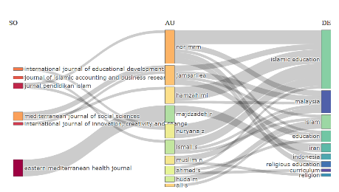
Figure 2.1. 6 Three Field Plot

Figure 2.1.7 explains the largest name both in terms of SCP or MCP, from the results of research data explains the 3 most published country samples, the first most publication in terms of SCP and MCP, namely Indonesia with the results of the publication of 468 SCP documents and 57 MCP documents, then continued with the Iranian state with the results of the publication of 297 SCP documents and 41 MCP documents, and Malaysia with the publication of 226 SCP documents and MCP results of 42 documents. From this much data, it can be explained that the publication is dominated by the Asian continent.
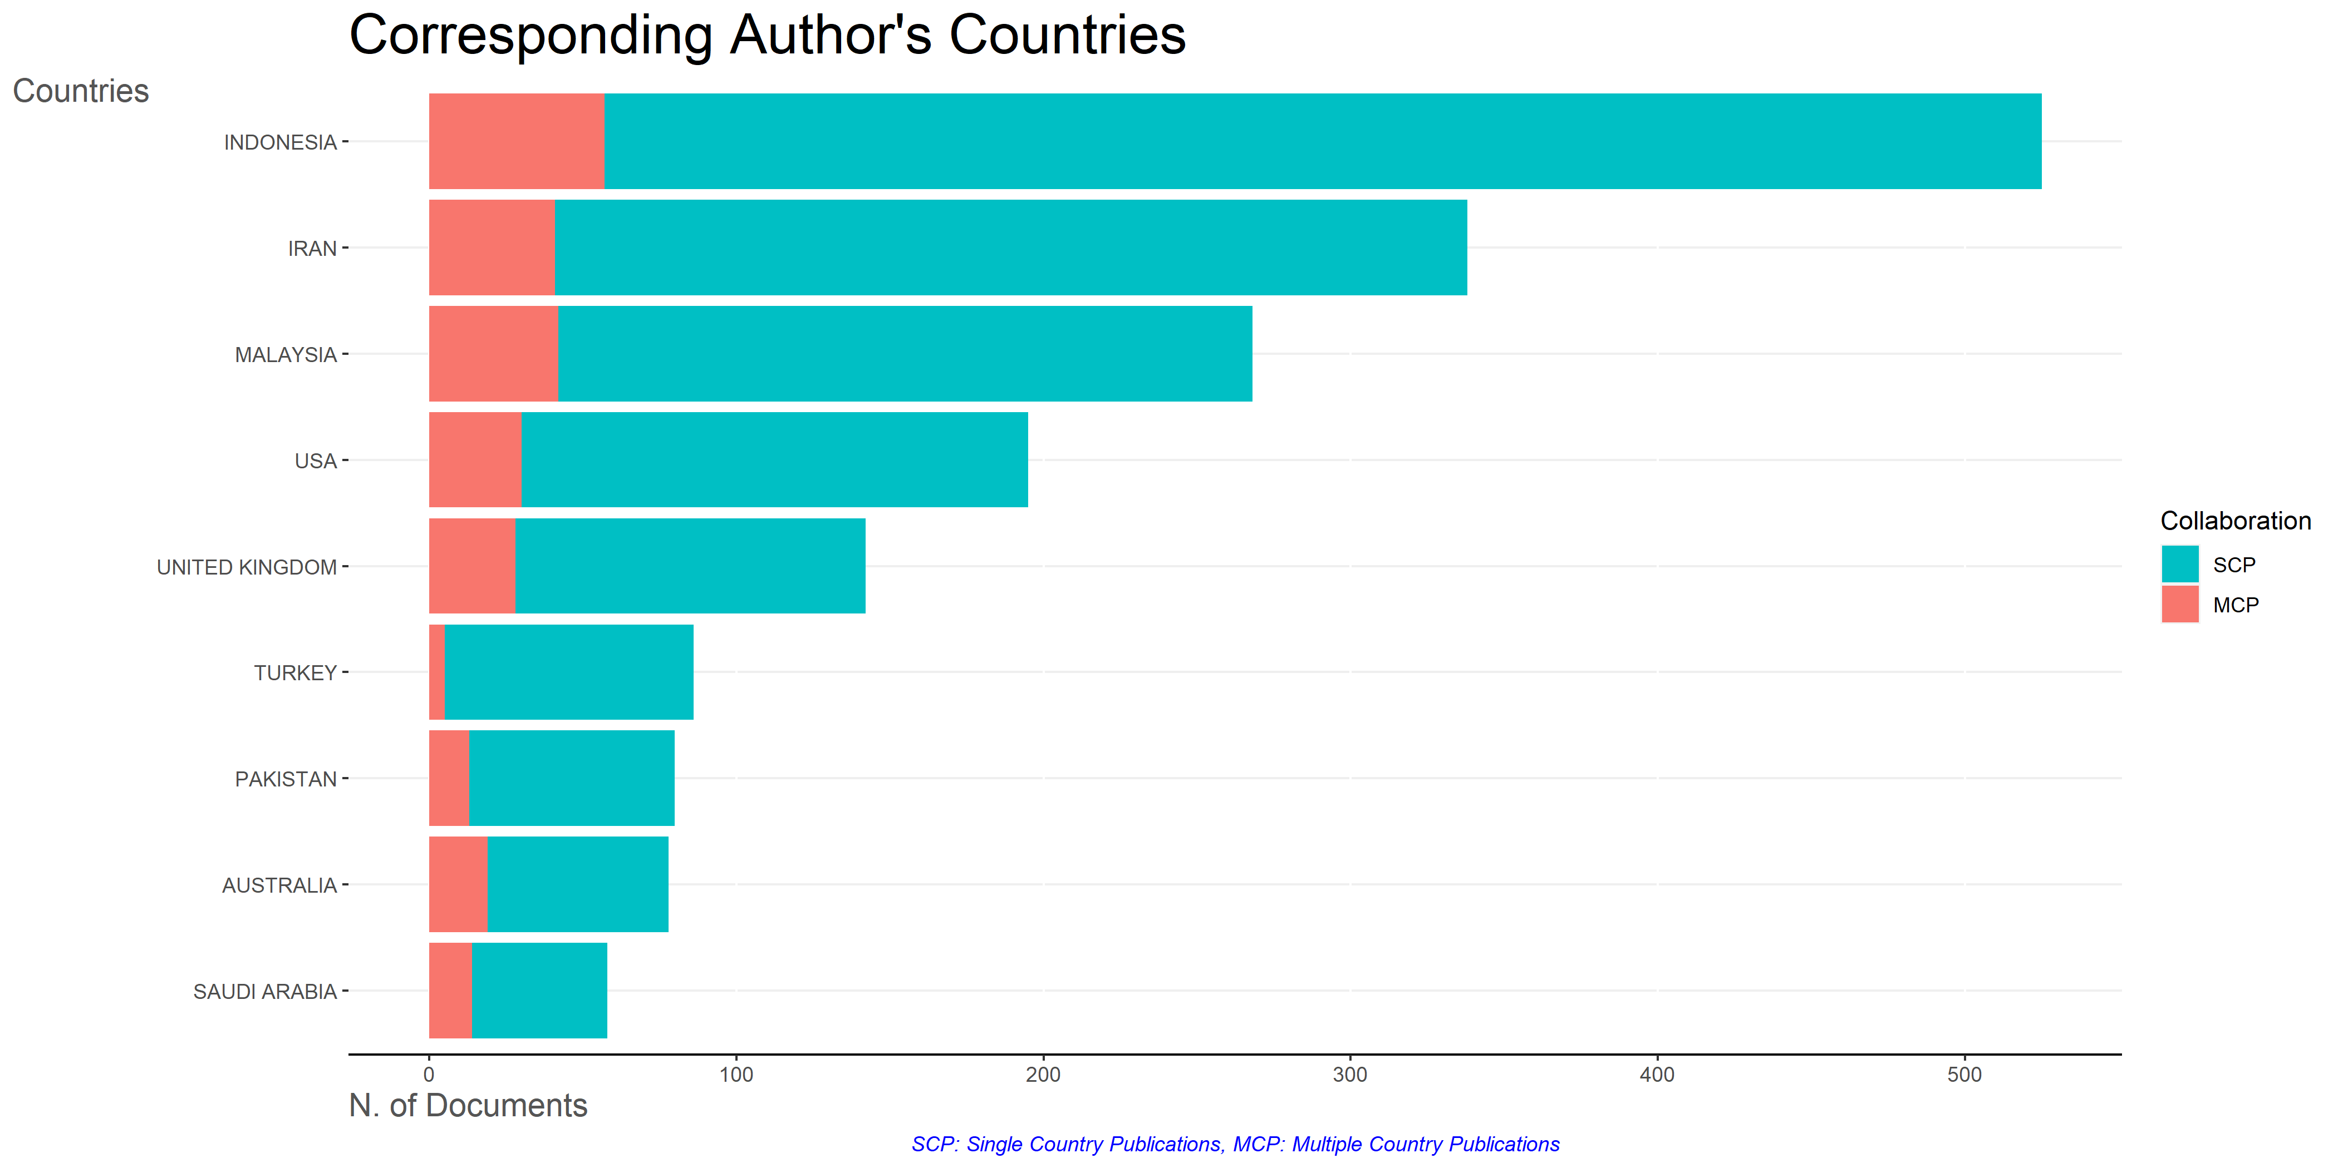
Figure 2.1. 7 Corresponding Author's Countries

The researcher explained 3 data on articles that have the most citations in table 2.1.2, the first largest article citation is Rollinson, 2013, Acta Trop with citation results of 405 and TC per year 36.82, the second Fleischma NN A, 2008, Bull Who with the number of citations 344 and TC results per year 21.50, and the third is Yousef DA, 2021, Press Rev with 269 citations and 11.7 TC results per year. It can be seen in the data table that the year of publication does not affect TC.
Table 2.1. 2 Most Global Cited Document
Paper | Total Citations | TC per Year
ROLLINSON D, 2013, ACTA TROP | 405 | 36.82
FLEISCHMANN A, 2008, BULL WHO | 344 | 21.50
YOUSEF DA, 2001, PERS REV | 269 | 11.70
BUIJS AE, 2009, LANDSC URBAN PLANN | 237 | 15.80
AL-QAHTANI AAY, 2013, J COMPUT ASSISTED LEARN | 184 | 16.73
WALL LL, 1998, STUD FAMILY PLANN | 181 | 6.96
HALSTEAD JM, 2004, COMP EDUC | 178 | 8.90
EICKELMAN DF, 1978, COMP STUD SOC HIST | 177 | 3.85
BERREBI C, 2007, PEACE ECON PEACE SCI PUBLIC POLICY | 173 | 10.18
ZINE J, 2006, EQUITY EXCELLENCE EDUC | 158 | 8.78

Discussion
- Network Analysis
Figure 2.2.1 describes the dataset with network co-occurrence analysis with a minimum cluster size of 15, the figure has 3 kinds of clusters, the first cluster is red with the number of items 39, the second cluster is green with the number of items 33, and the third cluster is blue with the number of items 27.
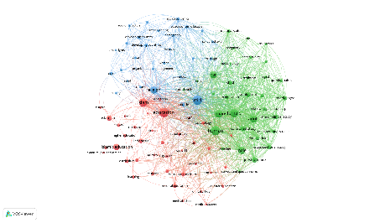
Figure 2.2. 1 Network Visualisation

Figure 2.2.2 shows keyword network analysis based on co-occurrence overlay. It can be seen that the words Article, Religion, and Culture are included in the keywords that are often used in 2012, while the keywords Islamic Education, Curriculum, and Male are keywords with relative use around 2014-2023 which are still current, so the researcher explained according to the data that has been found.
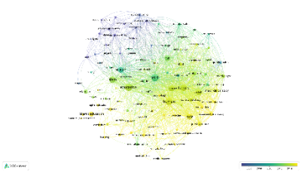
Figure 2.2. 2 Overlay Visualisation

In figure 2.2.3, researchers analyzed keywords that had the highest density with bright yellow data in the example keywords: Islamic, Education, and Female, as well as keywords that were rarely studied with blurred yellow data in the example keywords: Islamic Education, Curriculum, and Learning
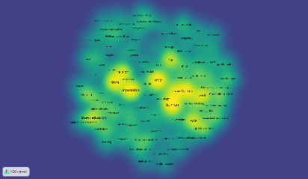
Figure 2.2. 3 Density Visualisation

Table 2.2.1 shows the co-occurrence density visualisation in each cluster that has a main theme in the field of Critical Thinking research. The theme in the first cluster is a Controlled Study item, the second cluster has an Active Learning item, and the third cluster has Cognition. An explanation of each cluster can be seen in the table below.
Table 2.2. 1 Keyword of Density Visualisation
Keyword | Occurances | Cluster
1. Islamism  2. Education  3. Islamic Religious Education  4. Curriculum  5. Higher Education | 185  578  39  102  83 | 1
1. Adolescent  2. Attitude to Health  3. Knowledge  4 Health Education.  5. Humans | 163  94  75  96  385 | 2
1. Behavior  2. Attitude  3. Culture  4. Family Planning  5. History | 36  71  55  50  45 | 3

Conclusion
The findings of this research are to determine the development and direction of Critical Thinking Islamic Education research between 1994 and 2023. The analysis was carried out at five broad levels of bibliometric indicators, namely scientific production, author, country level, affiliation, source or journal. This study also helps prospective researchers to gain new insights and trends in Critical Thinking of Islamic Education using bibliometric analysis. In this research it was found that the topic of the Critical Thinking Islamic Education was widely researched by the Indonesian state, there are still few who discuss topics from outside the country of Indonesia published in the journal Religion. This research was limited to articles indexed in Google Scholar data, and the Scopus database. Future research should include databases and others to track subject growth. This biliometric analysis serves as a descriptive tool, revealing information about the most influential articles. Therefore, it is hoped that writers in the future can study more deeply and thoroughly related to the Critical Thinking Islamic Education in the application of the use of this bibliometric study so that it is easier to read and also include citations of documents from Google Scholar, Scopus, and others.

References
Agbaria, A. K. (2019). Religion and the global middle class: towards a new research agenda. Discourse, 40(5), 734–742. https://doi.org/10.1080/01596306.2019.1602307
Ainissyifa, H., & Nurseha, A. K. (2022). CONTEXTUALIZING MAHMUD YUNUS’ ISLAMIC EDUCATION CONCEPT IN MADRASAH ALIYAH. Jurnal Pendidikan Islam, 8(1), 87–100. https://doi.org/10.15575/jpi.v8i1.19117
Alkouatli, C. (2018). Pedagogies in becoming muslim: Contemporary insights from islamic traditions on teaching, learning, and developing. Religions, 9(11). https://doi.org/10.3390/rel9110367
Altinyelken, H. K. (2021). Critical thinking and non-formal Islamic education: Perspectives from young Muslims in the Netherlands. Contemporary Islam, 15, 267–285.
Arif, M. (2019). Fundamentals of qur’anic education concept a critical conceptualization with special reference to Al-Kilani’s Thought. Global Journal Al-Thaqafah, 9(2), 15–26. https://www.scopus.com/inward/record.uri?eid=2-s2.0-85087011299&partnerID=40&md5=8a43fdfbc02687b4a9be19a155c174c8
Assingkily, M. S., & Mesiono, M. (2019). Karakteristik Kepemimpinan Transformasional di Madrasah Ibtidaiyah (MI) serta Relevansinya dengan Visi Pendidikan Abad 21. MANAGERIA: Jurnal Manajemen Pendidikan Islam, 4(1), 147–168. https://doi.org/10.14421/manageria.2019.41-09
Bafadhol, I. (2017). Lembaga pendidikan islam di indonesia. Edukasi Islami: Jurnal Pendidikan Islam, 6(11), 14.
Cahyo, S. D., Muslim, M. R. U., Rahman, A. N., & Pratolo, B. W. (2019). Needs analysis of Islamic-based english reading material for the Muhammadiyah junior high school. International Journal of Evaluation and Research in Education, 8(2), 286–292. https://doi.org/10.11591/ijere.v8i2.18647
Dhuhri, S., Hasan, H., Sakni, A. S., & Ismail, I. U. (2021). Passive Islamophobia and national cultural construction: A critical note on art curriculum. Indonesian Journal of Islam and Muslim Societies, 11(1), 1–27. https://doi.org/10.18326/IJIMS.V11I1.1-27
Dzati Amani, C. S. (2023). Konsep Critical Thinking Prespektif QS. Al-Alaq 1-5. Gunung Djati Conference Series, 19, 530–540.
Dzulkifli, I. (2021). Teaching and Learning AIDS to Support the Deaf Students Studying Islamic Education. Pertanika Journal of Social Sciences and Humanities, 29(4), 2263–2279. https://doi.org/10.47836/pjssh.29.4.09
Francis, L. J., McKenna, U., & Sahin, A. (2020). Exploring psalm 73:1–10 through sensing and intuition: The sift approach among muslim educators. HTS Teologiese Studies / Theological Studies, 76(3), 1–7. https://doi.org/10.4102/hts.v76i3.6093
Hamzah, M. I., Zhaffar, N. M., & Razak, K. A. (2018). Barriers in Teaching Critical Thinking in Islamic Education. Creative Education, 9(No.14). https://doi.org/https://doi.org/10.4236/ce.2018.914175
Hardaker, G., & Sabki, A. (2016). The nature of memorisation for embodiment. Journal for Multicultural Education, 10(1), 87–98. https://doi.org/10.1108/JME-01-2016-0019
Hussin, N. H., Noh, M. A. C., & Tamuri, A. H. (2014). The religious practices teaching pedagogy of Islamic education excellent teachers. Mediterranean Journal of Social Sciences, 5(16), 239–246. https://doi.org/10.5901/mjss.2014.v5n16p239
Ismail, N. K., & Zain, F. M. (2014). Tuan husain kedah: His influence and contribution in islamic education and development in kedah. Mediterranean Journal of Social Sciences, 5(29), 62–67. https://doi.org/10.5901/mjss.2014.v5n29p62
Judi, H. M., Noor, S. F. M., & Rahim, N. S. (2019). Visualisation method for effective presentation of Hadith commentary using cone tree. Journal of Engineering and Applied Sciences, 14(1), 62–67. https://doi.org/10.3923/jeasci.2019.62.67
Kazmi, Y. (2020). The Role of Critical Thinking in Islam, Hamdard Islamicus. Islamic Research Foundation International, Inc, 23 (1), 27–36.
Mohd Zhaffar, N., Hamzah, M. I., Abdul Razak, K., & Wan Abdullah, W. A. A. (2016). Ke Arah Guru Pendidikan Islam sebagai Pemikir Kritis. Sains Humanika, 8(3), 9–15. https://doi.org/10.11113/sh.v8n3.739
Mouftah, N. (2012). Eleanor Abdella Doumato and Gregory Starrett, editors, Teaching Islam: Textbooks and religion in the Middle East. Contemporary Islam, 6(1), 103–104. https://doi.org/10.1007/s11562-010-0136-5
Nasir Zakaria, G. A., Nawi, A., & Wekke, I. S. (2019). The effectiveness of implementing noble values through online problem-based learningamong students in higher learning institution. Journal of Advanced Research in Dynamical and Control Systems, 11(8 Special Issue), 540–556. https://www.scopus.com/inward/record.uri?eid=2-s2.0-85071312201&partnerID=40&md5=14cb95f473574a5e4af8df18db406417
Nawi, M. A. M., Zakaria, G. A. N., & Mahalle, S. (2014). A study of religious teacher’s readiness to teach outside the area of expertise. Social Sciences (Pakistan), 9(1), 20–23. https://doi.org/10.3923/sscience.2014.20.23
Noh, M. A. C., Ludin, M. S. M., & Suhid, A. (2013). Teaching competency among Islamic educators in Malaysia. World Applied Sciences Journal, 24(2), 267–269. https://doi.org/10.5829/idosi.wasj.2013.24.02.13198
Nuryana, Z. (2022). Academic reform and sustainability of Islamic higher education in Indonesia. International Journal of Educational Development, 89. https://doi.org/10.1016/j.ijedudev.2021.102534
Rahman, A. (2019). ISLAMIC LOCAL AWAKENING: STUDY OF MUHAMMADIYAH RENEWAL AS THE RISE OF ISLAMIC EDUCATION IDENTITY IN SOUTH SUMATERA. Jurnal Pendidikan Islam, 5(1), 65–74. https://doi.org/10.15575/jpi.v5i1.4039
Rohman, F. (2021). Watson-Glaser Critical Thinking Appraisal (WGCTA) Critical Thinking Ability Assesment in Fikih Learning With Watson- Glaser Critical Thinking Appraisal (WGCTA). Jurnal Penelitian Pendidikan Agama Dan Keagamaan, 19(3), 333–345. http://creativecommons.org/licenses/by-sa/4.0/
Sahakyan, N. (2018). Language debate and visions of the future in revolutionary Dagestan. Caucasus Survey, 6(2), 147–162. https://doi.org/10.1080/23761199.2018.1466603
Sai, Y. (2018). An exploration of ethos in Irish Muslim schools: ethnographic insights and perspectives from parents and teachers. Journal of Beliefs and Values, 39(1), 29–44. https://doi.org/10.1080/13617672.2017.1290374
Syaifullah, A. (2021). Critical Thinking: Pemecah Problema Pendidikan Islam Di Era Covid-19. Proceeding Antasari International Conference. https://doi.org/10.19105/tjpi.v15i1.2416.2

